Test Result Report
DWH Sales
Project Documentation

Background | Information needed to assess the effectiveness of the testing process and the current state of the project
Purpose | To provide the key information about the testing process and testing results.
Scope | Testing process description, test results, metrics, recommendations.
Audience | Management staff, QA team, project team.
File | Test Result Report.docx

Contents
- Summary
- Test team
- Testing process description
- New defects statistics
- New defects list
- Recommendations
- Attachments

Summary
During April 08–14, the dwh_hw_db data warehouse was tested across the LND, DWH, and DM layers.
Test cases were designed based on project documentation and business requirements. Testing included validation of data ingestion, transformation processes, and data consistency across all layers using the external source database (dwh_src_hw_db) as a reference.
Test execution statistics were based on test case results (pass/fail), while defect statistics were based on identified issues tracked in Jira.
The overall results indicate a moderate level of product quality with significant risks in critical data processing areas. While 64% of test cases passed, a substantial 36% failure rate highlights unresolved issues affecting system reliability.
The 100% pass rate for smoke tests confirms basic system stability. However, the low success rate of critical path tests (36.36%) indicates major issues in core business logic and data processing flows, posing a high risk for production readiness.
The extended path tests (71.4% passed) demonstrate that non-critical scenarios are generally handled correctly, though some inconsistencies remain.
The system demonstrates basic operational stability but is not ready for release due to failures in critical business scenarios. Immediate focus is required to resolve high-impact defects to ensure data accuracy and reliability of the data warehouse.

Test team
Name | Role | Responsibility
Nataliia Homon | Tester | Documentation creation, testcases creation, execution

Testing Process Description
During the reporting period (April 15–17), testing activities were conducted for the dwh_hw_db data warehouse in a controlled environment.

Test Environment
- Database Management System: PostgreSQL 18.0 (x86_64-windows, compiled by msvc-19.44.35217, 64-bit)
- Operating System: Windows 11 Home
- Client Tool: DBeaver

Testing Approach
All testing activities were performed manually through execution and validation of SQL scripts.
The primary test artifact used was “Task6 Test cases.sql” (attached).
Test case design was based on the available project documentation, data models, and business requirements for the dwh_hw_db data warehouse.
Testing covered the following data layers:
- LND (Landing layer) – validation of raw data ingestion
- DWH (Core layer) – validation of transformation logic and data consistency
- DM (Data Mart layer) – validation of aggregated and business-ready data

ETL Validation Scope
End-to-end data flow validation was performed according to the ETL pipeline logic:
Source schemas (s1, s2 in dwh_src_hw_db) → LND → DWH → DM (dwh_hw_db)
Validation included:
- data extraction accuracy from source systems
- correctness of transformations and mappings
- data consistency across layers
- completeness and integrity of loaded data

Test Execution Scope
The following test types were executed:
- Smoke testing – basic validation of data availability and pipeline execution
- Critical path testing – validation of core business logic and key data flows
- Extended path testing – validation of non-critical and edge-case scenarios
Overall Testing Statistics 64% passed (16/25 tests) 36% failed (9/25 tests)
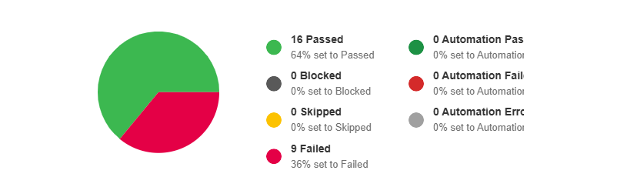
By Test Sections
Smoke tests: 100% passed
Critical path tests: 36.36% passed
Extended path tests: 71.4% passed
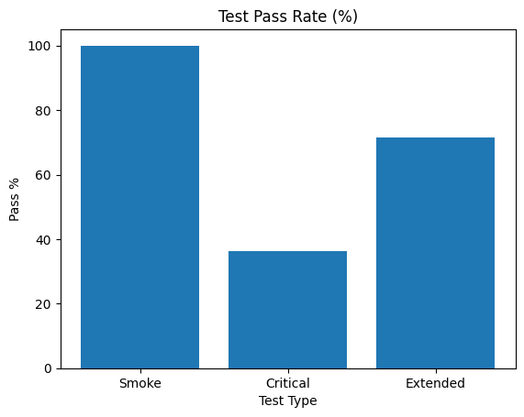
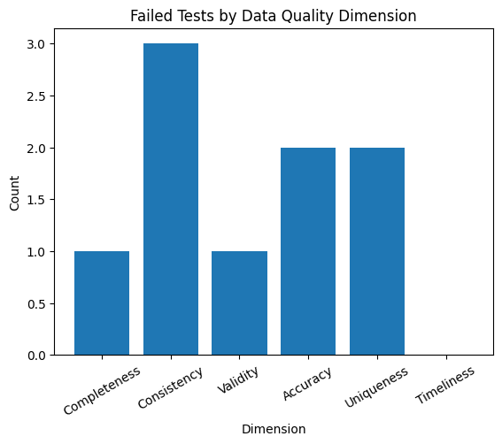

Defect Management
All identified defects were logged and tracked in Jira under Scrum Sprint 1.
Defect reporting included detailed reproduction steps, SQL evidence, and expected vs actual results to support efficient resolution.

New Defects Statistics
Severity Distribution
Status | Quantity | Trivial | Minor | Major | Critical
Submitted | 15 | 0 | 8 | 7 | 0
Fixed | 0 | 0 | 0 | 0 | 0
Verified | 0 | 0 | 0 | 0 | 0
Reopened | 0 | 0 | 0 | 0 | 0
Declined | 0 | 0 | 0 | 0 | 0

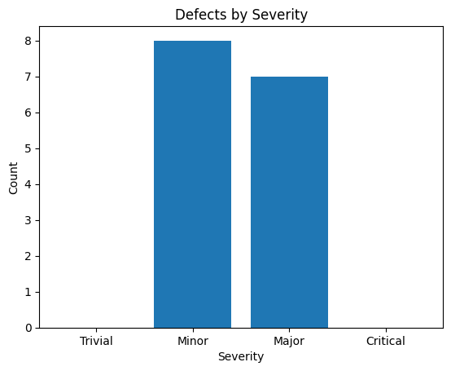
Priority Distribution
Status | Quantity | Low | Medium | High
Submitted | 15 | 3 | 8 | 4
Fixed | 0 | 0 | 0 | 0
Verified | 0 | 0 | 0 | 0
Reopened | 0 | 0 | 0 | 0
Declined | 0 | 0 | 0 | 0

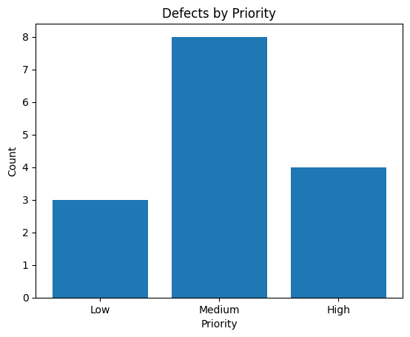
New defects list
ID | Severity | Priority | Summary
- SCRUM-1592 | Major | High | Wrong SCD type 2 logic - DWH_ VALID_TO <= VALID_FROM in dwh_clients
- SCRUM-1604 | Major | High | DWH_ TOTAL_COST is calculated wrongly in DM_MAIN_DASHBOARD based on DWH data
- SCRUM-1789 | Major | High | DWH_Mismatch in numeric aggregates between LND and DWH for SALES quantity and PRODUCT cost
- SCRUM-1797 | Major | High | DWH_Data mismatch between SRC and LND layers for numeric fields
- SCRUM-1584 | Major | Medium | DWH_mismatch lnd.lnd_s1_clients + lnd.lnd_s2_clients =>dwh.dwh_clients
- SCRUM-1593 | Major | Medium | DWH_Data inconsistency between DWH_SALES and DM_MAIN_DASHBOARD (row count and distinct products mismatch)
SCRUM-1742 | Major | Medium | DWH_Duplicate records found in DM_MAIN_DASHBOARD
SCRUM-1570 | Minor | Medium | DWH_wrong column name channellocation in lnd_s1_channels
- SCRUM-1581 | Minor | Medium | DWH_wrong column name in dm.dm_main_dashboard - client_iast_name
- SCRUM-1582 | Minor | Medium | DWH_wrong column name in dwh_clients - first_purrchase_date
- SCRUM-1583 | Minor | Medium | DWH_mismatch src(s1.s1_clients) target (lnd_s1_clients )
SCRUM-1690 | Minor | Medium | DWH_Mismatch in product_id between SRC (s1_products) and LND (lnd_s1_products)
- SCRUM-1585 | Minor | Low | DWH_mismatch in client phone number lnd=>dwh
- SCRUM-1711 | Minor | Low | Начало формы  DWH_Email mismatch between DWH_CLIENTS and DM_MAIN_DASHBOARD for two customers
- SCRUM-1736 | Minor | Low | DWH_ Duplicate client records found in LND_S1_CLIENTS based on client_id

Defects by Data Layer
Layer | Number of Issues
LND | 8
DWH | 7
DM | 5

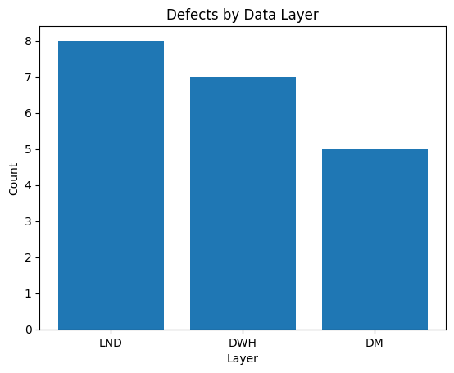

Recommendations
Based on the test execution results and defect analysis, the following actions are recommended:

1. Stabilize Data Ingestion (LND Layer)
A high number of defects in the LND layer indicates issues with data extraction and loading from source systems.
Recommended actions:
- Validate data mapping rules between source systems and LND
- Implement additional data validation checks during ingestion
- Ensure consistency between multiple source schemas (s1, s2)
- Introduce duplicate detection and handling mechanisms

2. Fix Transformation Logic in DWH Layer
Defects related to SCD Type 2, aggregations, and data mismatches highlight problems in transformation logic.
Recommended actions:
- Review and correct SCD Type 2 implementation logic
- Validate aggregation rules and numeric calculations
- Ensure consistency between LND and DWH data
- Add unit-level validation for transformation queries

3. Improve Data Consistency Across Layers
Data mismatches between SRC → LND → DWH → DM indicate lack of end-to-end validation.
Recommended actions:
- Implement automated reconciliation checks between layers
- Add data quality rules (row counts, checksums, aggregates)
- Introduce monitoring for ETL data consistency

4. Validate Business Logic in DM Layer
Issues in DM layer (e.g., incorrect TOTAL_COST, duplicates) affect analytical accuracy.
Recommended actions:
- Revalidate business calculation logic in DM layer
- Ensure correctness of joins and aggregations
- Add validation for final reporting datasets

5. Enhance Test Coverage for Critical Scenarios
Low pass rate in critical path tests (36.36%) indicates insufficient reliability of core functionality.
Recommended actions:
- Prioritize fixing defects in critical path scenarios
- Expand test coverage for key business flows
- Introduce regression testing for critical logic

6. Improve Data Quality Controls
Presence of duplicates, null issues, and inconsistencies suggests weak data quality governance.
Recommended actions:
- Implement data quality rules (uniqueness, null checks, referential integrity)
- Introduce constraints where applicable
- Add automated data validation scripts

7. Strengthen Defect Resolution Process
A significant number of failed tests indicates the need for faster defect resolution.
Recommended actions:
- Prioritize high-severity defects (Major, Critical)
- Ensure clear communication between QA and development teams
- Track defect resolution progress within sprint cycles

Overall, it is recommended to focus on stabilizing the ETL pipeline, improving transformation logic, and implementing comprehensive data validation mechanisms to ensure data accuracy and production readiness.

Attachments
- Jira reports - SCRUM Sprint 1 - DQ Module Team - Scrum Board - Jira
- Test runs and results - https://dqau25in25.testrail.io/index.php?/runs/view/77&group_by=cases:section_id&group_order=desc&display=tree
- Test scripts (Data_Quality_Task_9) - https://github.com/NatalyHomon/AU25_Nataliia_Homon

